Sprint 2- Accuracy Design Document

November 24, 2019

Jenni, Griffin, Angaya

Executive Summary

## Project Overview

The robot will be activated and programed through the Sphero Edu app. In part two of the project, all team members will continue to collaborate creating an algorithm that**is developed and tested to fulfill all functional requirements.**The team’s focus will be on the accuracy of the robot and its ability to complete sprint two. To observe the robot’s accuracy through its run, the robot must travel around a given perimeter of a figure eight, five times. Once the robot passes through the directed path and ends at the original starting point, the team can verify the algorithm works well. Thus, the robot proves it accuracy. We demonstrate this to the class and the professor with documentation of the robot’s run to demonstrate the effectiveness of our algorithm and the accuracy of our robot during its second sprint.

## Purpose and Scope of this Specification

In scope

This document addresses requirements related to phase 2 of the software development project: Accuracy, sprint 2. Our audience is class CS-104 01.

Out of Scope

Phase 1 & 3 of the system development project is not included in this document.

# Product/Service Description

The robot, just as in phase 1 of the project, should be charged and connected to the Sphero app to verify its capability to execute the algorithm. In addition, there should be no physical barrier obstructing its navigation. Any barriers in the robot’s pathway could pose a possible delay to the robot’s potential of achieving the functional requirements. If barriers prove an issue, all team members will work to improve the algorithm to suit accordingly. The algorithm must be well developed to make sure the robot stays on path, especially since the focus is accuracy.

## Product Context

The robot is relatively similar to other products in that it is programmed through a block code program of a user-friendly app. In the Sphero.edu app, team members create an algorithm to direct the robot through its sprint. Thus, the robot is dependent on the app and its user. Other outside sources that are as important include Bluetooth connection. Without the link of the robot to the app, we cannot work on test runs. The connection of the robot to the app is just as important as an effective algorithm. The user is also responsible in being precise in creating an algorithm that proves accuracy during the sprint.

## User Characteristics

The general customer profile includes: Freshman student in CS-104 01 at Monmouth University with about 2-3 months' worth of experience on the Sphero.edu app and using block code.

## Assumptions

Easy access to the Sphero.edu app is expected to ensure a smooth process in creating an algorithm for the robot. When the main operating system is working properly, the user should be able to adjust if necessary. Large spaces, or lack thereof, also may force the user to adjust distances written in our algorithm. Depending on the setting, the user may have to observe closely to note if it poses an issue. Close observation is essential in phase 2 because accuracy and preciseness are the center of attention.

## Constraints

There are many constraints team members have noted: trouble connecting the app to the robot, block code program on sphero.edu is not executed properly, lacking access to the app, not being able to create an efficient algorithm, all team members not being able to physically meet, lack of space at the testing site, a potential difference of measurements from software development project outline, and a list of more challenging requirements to meet .

## Dependencies

The robot must be fully charged before every test run. The user must make sure the robot is connected to the Sphero app to confirm a successful run. The block code algorithm must also be well-organized before a test run. The block code, in addition, should be according to the software development project outline, otherwise not effective. Since accuracy is the main focal point, the algorithm must be adjusted often to ensure quality of each requirement fulfillment.

# Requirements

| Req# | Requirement | Comments | Priority | Date Rvwd | SME Reviewed / Approved |
| --- | --- | --- | --- | --- | --- |
| ACC_01 | Robot must be fully charged and in a spacious area | No physical barrier should be in pathway | 1 | 11/24/20 | Reviewed & approved |
| ACC_02 | Robot must start at a given starting point, then head in 0 degrees + delay for 0.5 sec |  | 1 | 11/24/20 | Reviewed & approved |
| ACC_03 | At a speed of 55 the robot must spin 360 degrees for 2.5 sec. and spin -360 degrees for 2.5 sec in a loop 5 times |  | 1 | 11/24/20 | Reviewed & approved |
| ACC | Robot must speak “I am the winner” and wait |  | 1 | 11/24/20 | Reviewed & approved |
| ACC | Another loop will be integrated, beginning to flash multicolored led lights 1 sec each for 5 sec. |  | 1 | 11/24/20 | Reviewed & approved |
| ACC | Program should end |  | 2 | 11/24/20 | Reviewed & approved |

## Security

### Protection

Pathway should be clear for the robot to pass. There should be no physical barrier keeping the robot from executing functional requirements. Robot should be closely observed during its run to affirm the robot does not collide with any outside object. User should also keep algorithm under their account in a private folder to make certain there is no threat to the robot. This makes sure outside sources cannot have access to the robot’s program. The algorithm must be tested regularly to ensure it is most effective.

### Authorization and Authentication

Team members will use Github.com in-order to access all separate components of the project individually. Here all information will be easily accessible and will allow each team member to commit their work. One team member will create a repository to allow certain people access to the project documentation.

## Portability

In this project downloading Shero.edu app is required. Block code language is also the most recommended for an orderly algorithm. In addition, a spacious and orderly environment is suggested as the sprint is based on accuracy. Robot must also be cared for and not be damaged in any way, as that might affect performance  
If portability is a requirement, specify attributes of the system that relate to the ease of porting the system to other host machines and/or operating systems. For example,

# Requirements Confirmation/Stakeholder sign-off

|  |  |  |
| --- | --- | --- |
| Meeting Date | Attendees (name and role) | Comments |
| 11/24/20 | Jenni | confirmed all requirements |
| 11/24/20 | Griffin | Confirmed all requirements |
| 11/24/20 | Angaya | Conformed all Requirements |

# System Design

## Algorithm

|  |
| --- |
| 1. Heading in 0 degrees |
| 1. Main Led = blue |
| 1. Speed of 55 |
| 1. Loop 5 times: spin of 360 degrees for 2.5 sec; spin of -360 for 2.5 sec. |
| 1. Speak “I am the winner” and wait |
| 1. Loop forever: multicolored flashing for 5 sec. |
| 1. Program ends |

## System Flow

.

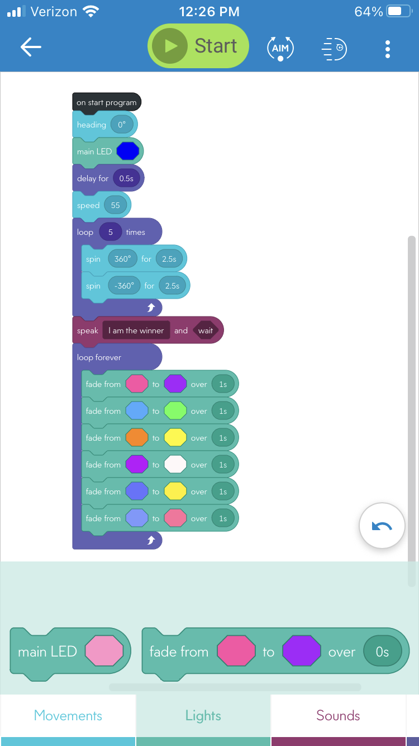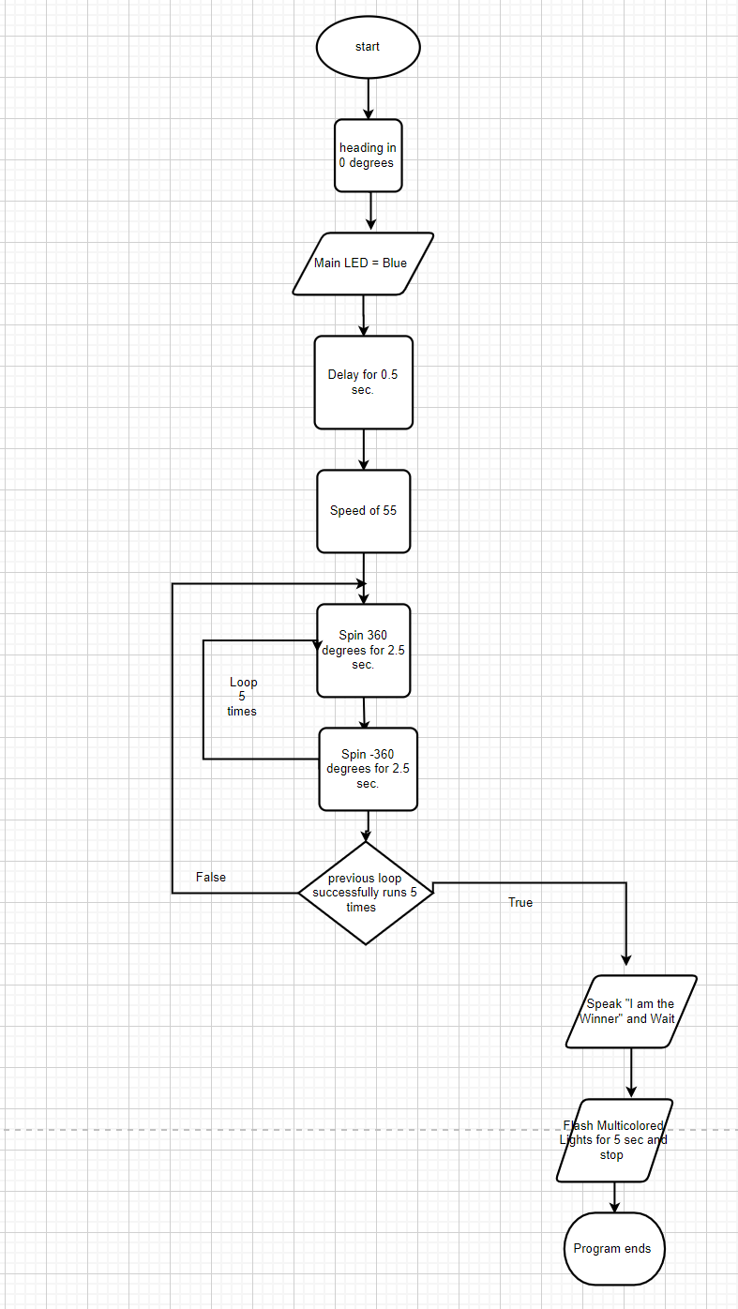

## Software

The team used block code program on the Sphero.edu app. Through the app, we can control the robot’s travel of speed, distance, and time. We will also see the sensor data diagram and all the robot’s movement.

## Hardware

The team uses a robot that connects to the Sphero.edu app through Bluetooth. The user also uses his/her phone to use the program easily, thus controlling the robot’s performance.

## Test Plan

| **Reason for Test Case** | **Test Date** | **Expected Output** | **Observed Output** | **Staff Name** | **Pass/Fail** |
| --- | --- | --- | --- | --- | --- |
| To observe if robot can head in the right direction, precisely with a sufficient speed |  | Robot will complete its task in heading the right direction, with a precise speed |  |  |  |
| To observe if robot starts in the given starting point; can accurately begin traveling towards the figure eight completion | 11/24/20 | Robot will start at given starting point and begin traveling towards the figure eight completion | Robot starts at the correct starting point and travels correctly towards figure eight | Griffin | pass |
| To observe the robot can follow a loop and complete the figure eight 5 times | 11/24/20 | Robot will follow a loop and complete figure eight 5 times | Robot follows loop and completes figure eight 5 times | Griffin | pass |
| To observe if the robot can speak and wait when it should | 11/24/20 | Robot will speak and wait when it should | Robot speaks and wait after figure eight completion | Griffin | Pass |
| To observe if the robot can accurately follow another loop and flash multicolored lights for 5 sec. | 11/24/20 | Robot will follow a loop and flash multicolored lights for 5 sec | Robot follows loop and flashes multicolored lights for 5 sec | Griffin | Pass |
| To observe if Robot ends at original starting point and exits program | 11/24/20 | Robot will end at original starting point and exits program | Robot ends at original starting point and exits program | Griffin | Pass |

## Task List/Gantt Chart

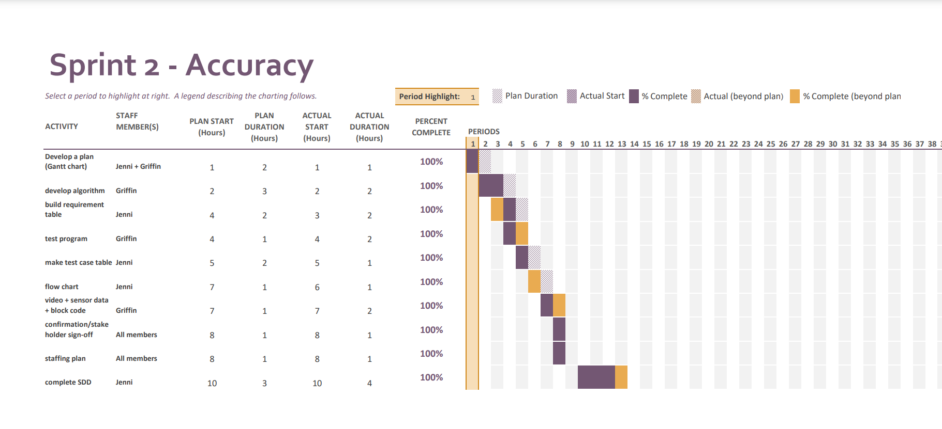

## Staffing Plan

| Name | Role | Responsibility | Reports To |
| --- | --- | --- | --- |
| Jenni | System design document | Fill out documentation in the SDD | GitHub repository called ‘Accuracy’ |
| Griffin | create + test algorithm | Create algorithms + run sprint tests | GitHub repository called ‘Accuracy’ |
| Angaya | Flowchart | Create a flowchart of the algorithm | GitHub repository called ‘Accuracy’ |